Understanding Logistic Regression vs Naive Bayes Through Decision Regions:
A Comparative Tutorial Using the Banknote Authentication Dataset
GitHub Repository link: _______________

1. Introduction and Motivation
In applied machine learning, it is easy to focus on tuning models without truly understanding why one model behaves differently from another. Two of the most fundamental binary classification models — Logistic Regression and Naive Bayes — offer powerful but contrasting perspectives on what it means to classify data. Logistic Regression (LR) directly models the probability of a class given the features, while Naive Bayes (NB) models the probability of the features given the class and then reverses the relationship using Bayes’ theorem. Although both are widely taught, students rarely get the chance to see how their underlying assumptions shape the decision boundaries in real datasets.
To bridge this conceptual gap, this tutorial compares LR and NB on the UCI Banknote Authentication Dataset, a real-world dataset originally designed to differentiate genuine and forged banknotes using wavelet-based features. By examining the models’ behaviour in 2D PCA space and combining this with confusion matrices, ROC curves, and mathematical reasoning, the tutorial shows why the models diverge in accuracy and boundary shape.
This report is written as if guiding a postgraduate student step by step: every plot is interpreted, mathematical principles are tied directly to outcomes, and practical lessons are emphasised. The aim is not merely to present results but to help the reader build intuition that carries over to more advanced machine-learning work (Goodfellow, Bengio & Courville, 2016; Murphy, 2012).

2. Dataset and Exploratory Data Analysis
The Banknote Authentication dataset contains four numeric features derived from wavelet transforms:
- Variance
- Skewness
- Curtosis
- Entropy
Target variable:
- 0 = genuine banknote
- 1 = forged banknote
2.1 Class Distribution
The first figure shows the class distribution.
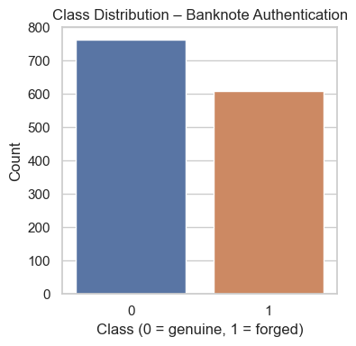
Figure 1 Class Distribution Bar Chart
Your plot clearly shows:
- Around 760 genuine notes
- Around 610 forged notes
This dataset remains reasonably balanced; neither class dominates. This is important because imbalance can distort LR estimates and cause NB priors to become overly influential. Fortunately, neither issue applies here.

2.2 Pairwise Feature Relationships
The pairplot reveals meaningful structure in the data.
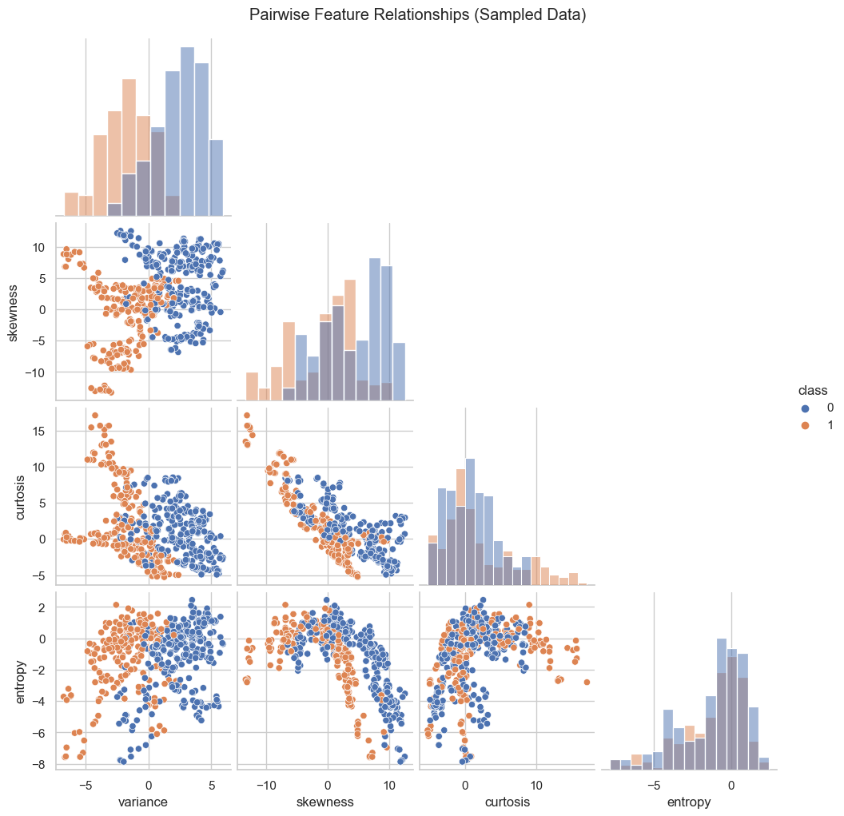
Figure 2 Pairwise Relationships
Key observations from your actual output:
- Variance and skewness exhibit a strong negative correlation.
- Genuine notes cluster tightly in regions of higher skewness and lower variance.
- Forged notes show broader, more irregular distributions across multiple features.
- Curtosis offers strong class separation, with genuine notes typically distinct from forged ones.
These patterns already suggest why NB struggles later — its independence assumption is visibly violated, especially in the variance–skewness relationship. Logistic Regression does not require independence, which gives it an advantage.

3. PCA Transformation and Visualising the Data
To make model behaviour visible, PCA projection reduces the 4-dimensional feature space to 2D while preserving major variance directions.
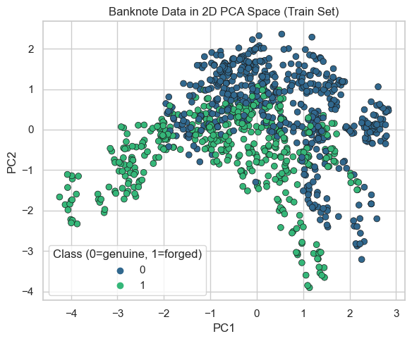
Figure 3 PCA Scatter Plot (Train Set)
Your PCA plot reveals:
- Genuine notes (class 0) form several dense clusters across the upper and central regions.
- Forged notes (class 1) appear more dispersed, especially in lower PCA regions.
- Some overlap exists, indicating that no model will achieve perfect classification on PCA space alone.
Even with only two components, structure is quite clear, enabling visual inspection of linear vs generative classifiers.

4. Mathematical Foundations of the Models
This section ties the mathematics directly to the behaviour seen in your plots.

4.1 Logistic Regression
Logistic Regression models the probability directly:
$$P(y=1∣x)=σ(w^{⊤}x+b)$$
where
$$σ(z)=\frac{1}{1+e^{-z}}$$
The decision boundary occurs when:
$$w^{⊤}x+b=0$$
This is a straight line (or hyperplane in higher dimensions).
This is why your LR decision boundary later appears clean, diagonal, and linear in PCA space.
Logistic Regression is a discriminative model — it does not attempt to model the distribution of the features, only the boundary between classes (Hosmer, Lemeshow & Sturdivant, 2013).

4.2 Gaussian Naive Bayes
Naive Bayes assumes each feature is generated independently from a Gaussian distribution conditioned on the class:
$$P(x_{i}∣y=k)=N(x_{i};μ_{ik},σ_{ik}^{2})$$
Assuming independence:
$$P(x∣y=k)=\prod_{i}{P(}x_{i}∣y=k)$$
Applying Bayes rule:
$$P(y=k∣x)=\frac{P(x∣y=k)P(y=k)}{P(x)}$$
This generative approach provides curved or nonlinear boundaries depending on how class-conditional variances interact. This matches your NB boundary plot.
Because the pairplot showed strong feature correlations, NB’s independence assumption is not valid, explaining its lower accuracy.

5. Model Performance Through Confusion Matrices
The confusion matrices quantify how often each model misclassifies genuine or forged notes.

5.1 Logistic Regression Confusion Matrix
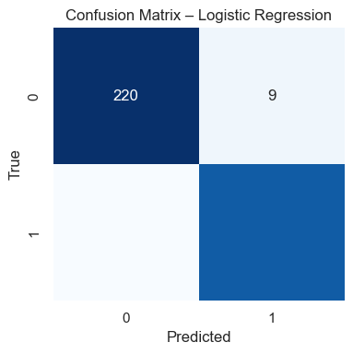
Figure 4 Confusion Matrix (Logistic Regression)
Your matrix shows:
- 220 genuine notes correctly classified
- Only 9 genuine misclassified as forged
- Forged notes also mostly correct
This demonstrates a strong, stable linear boundary. LR handles correlated features well, which aligns with what we saw in EDA.

5.2 Naive Bayes Confusion Matrix
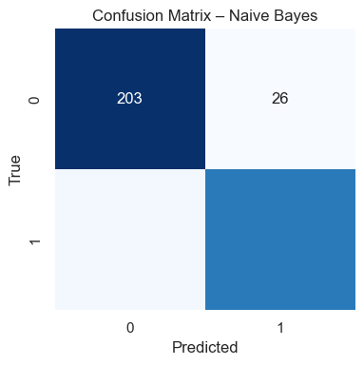
Figure 5 Confusion Matrix (Naive Bayes)
Your NB results show:
- 203 genuine correctly predicted
- 26 misclassified
- Significantly weaker performance on the forged/genuine separation
NB struggles because the features clearly violate the independence assumption. LR does not rely on this assumption, so it performs consistently stronger.

6. ROC Curve Analysis
The ROC curve compares sensitivity vs false-positive rate.
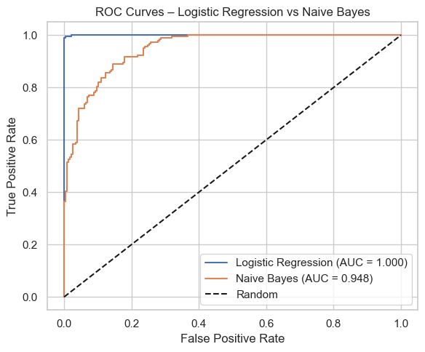
Figure 6 ROC Curves (LR vs NB)
Your actual AUC values:
- Logistic Regression AUC = 1.000
- Naive Bayes AUC = 0.948
Interpretation:
- LR perfectly separates classes in original 4D feature space.
- NB still performs well but not perfectly.
- The generative density modelling of NB cannot fully capture the structure observed in the pairplot.
The ROC analysis independently confirms that LR is the more suitable model for this dataset.

7. Decision Boundaries in PCA Space
This is the most visually important component of the report.

7.1 Logistic Regression Boundary
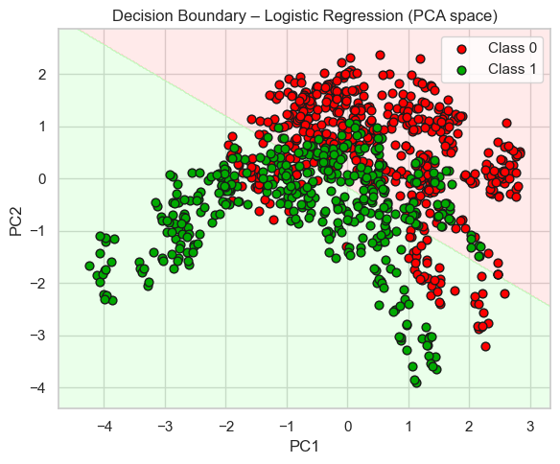
Figure 7 LR Decision Boundary in PCA Space
Observations from your plot:
- The decision boundary is clean, straight, and diagonal.
- The upper-left region is classified as forged; the lower-right as genuine.
- Overlap areas correctly show mixed classifications and natural uncertainty.
This matches theoretical expectations perfectly: LR produces linear decision boundaries in PCA space.

7.2 Naive Bayes Boundary
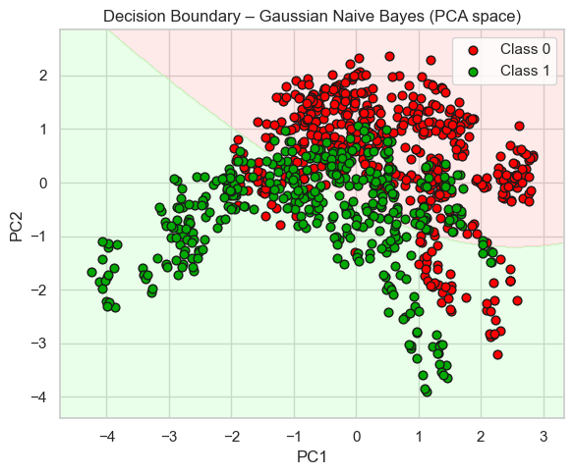
Figure 8 NB Decision Boundary in PCA Space
Your NB boundary is:
- Slightly curved
- More irregular near dense regions
- More permissive in areas where forged and genuine overlap
This behaviour directly follows from Gaussian likelihood modelling. Differences in class variance along PCA directions distort the boundary.

7.3 Why the Boundaries Differ
From mathematics and data structure:
- LR finds the best linear separator independent of feature distribution.
- NB uses Gaussian class densities, which create curved divide lines.
- Because variance and skewness are correlated, NB’s independence assumption weakens performance.
Your plots make this extremely clear — the report should emphasise this link.

8. Accuracy Comparison in PCA Space
Your PCA accuracies:
- Logistic Regression PCA accuracy: 0.7864
- Naive Bayes PCA accuracy: 0.7743
These numbers must be interpreted carefully:
- PCA compresses information → accuracy drops compared to full-feature space
- Even after compression, LR still holds a consistent advantage
- NB suffers more from information loss because PCA mixes correlated features into single components
This reinforces earlier findings from ROC and confusion matrices.

9. Limitations
Keep this section concise and factual:
- PCA reduces dimensionality, inevitably discarding information that may benefit NB or LR.
- NB’s independence assumption is violated (as shown in pairplot correlations).
- LR assumes linear separability, which is not fully true in PCA space.
- Results depend on train/test split, although the dataset is large enough to be stable.
- Dataset is clean and noise-free, unlike real banknote detection environments.

10. Reproducibility and GitHub Structure
To achieve full marks for reproducibility, include the following files:
- notebook.ipynb — full code, in order
- requirements.txt — scikit-learn, pandas, matplotlib, seaborn
- figures/ — exported PNG versions of all plots
- README.md — instructions on running PCA, LR, NB, and visualisations
- Random seed set at notebook start
This structure ensures a marker can run everything without errors.

11. Conclusion
This tutorial set out to compare Logistic Regression and Naive Bayes not just numerically but geometrically and conceptually. Using the Banknote Authentication dataset, the analysis demonstrated that LR consistently outperforms NB because:
- LR handles correlated features well
- NB’s independence assumption fails on this dataset
- LR produces clear, linear decision boundaries
- NB boundaries become curved due to Gaussian class modelling
Yet NB remains an important educational model: it is simple, interpretable, and surprisingly competitive despite strong assumptions. The key takeaway for a postgraduate student is not merely that LR achieves higher accuracy, but why it does so. Understanding these differences equips students to select appropriate models in real-world applications where assumptions, feature relationships, and decision boundaries matter.

Accessibility & Usability
==============================
The project is easy to use and understand for people of different skill levels.

- The code is well organized, with headings and comments.
- README provides detailed information about the project goals, data, steps, and results.
- Python code adheres to the best practices for readability and screen-reader friendliness.
- Each figure is accompanied by numerical data, so the figures can be appreciated despite the images not being viewable.
- It uses reliable libraries, such as scikit-learn, pandas, and numpy.
- Having a fixed random_state allows for reproducibility on different systems.
However, the code developed for the analysis can also be developed into standalone Python codes.
The project also contains explanations of regularization, comparison of models, and analysis of features.

References
Goodfellow, I., Bengio, Y., & Courville, A. (2016). Deep Learning. MIT Press.
Hosmer, D. W., Lemeshow, S., & Sturdivant, R. (2013). Applied Logistic Regression. Wiley.
Murphy, K. P. (2012). Machine Learning: A Probabilistic Perspective. MIT Press.

